Name: Max Gordon
Date: 3/31/20
16.06 Picture Lab Worksheet
Directions: Make note of your responses to the following questions as you work through the activities and exercise in the lesson.

Activity 8 Exercise Results

- Paste the image that is the result of calling the second copy method that adds parameters to allow you to copy just part of the fromPic.
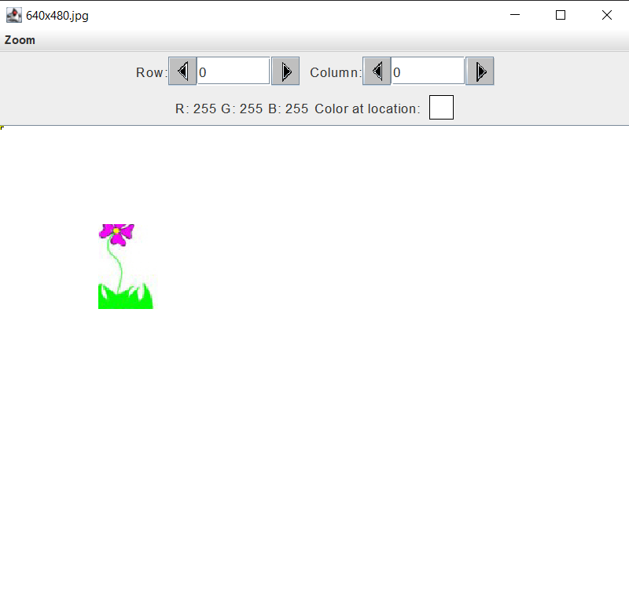
- Paste the image that is the result of calling the myCollage method.
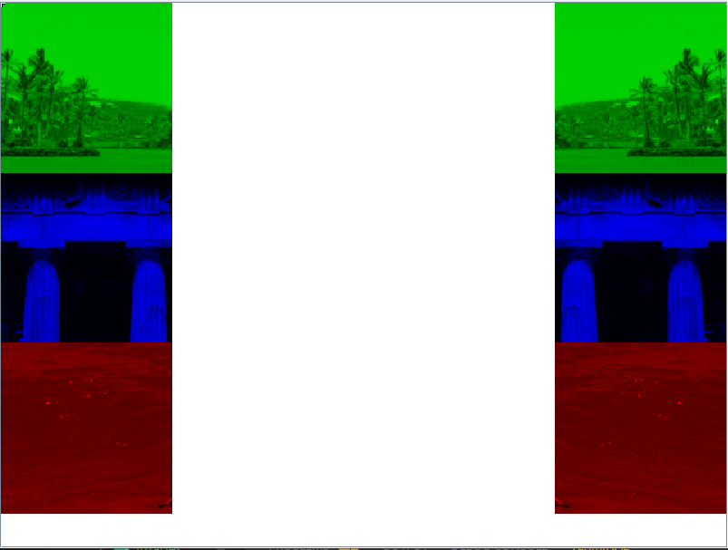
Activity 9 Exercise Results
- Paste the image that is the result of calling the edgeDetection2 method.
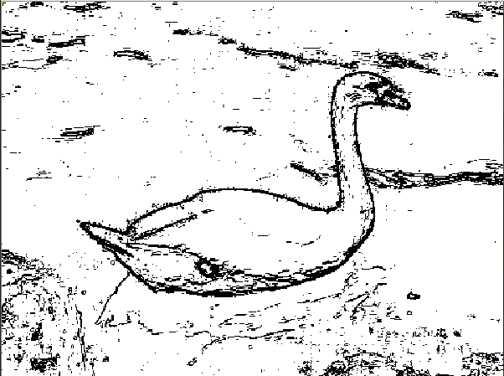
- Think about and propose another algorithm for edge detection.
I think a better way to do edge detection is to not just compare the pixel to the most immediate one, but also pixels a bit further from it (but weight them less in the comparison). This would prevent the case of an obvious edge, but there is enough of a gradient between two adjacent pixels that the algorithm doesn’t identify it as an edge.

